**EXPERIMENT 3**

Q1

<?php

echo "20438 UMME ATIYA</br><hr>";

$num=407;

$total=0;

$x=$num;

while($x!=0)

{

$rem=$x%10;

$total=$total+$rem*$rem*$rem;

$x=$x/10;

}

if($num==$total)

{

echo "Yes it is an Armstrong number";

}

else

{

echo "No it is not an armstrong number";

}

?>

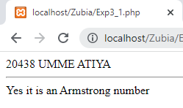

Q2

<?php

echo "20438 UMME ATIYA</br><hr>";

$num=121;

$p=$num;

$rev=0;

while($num!=0){

$rev=($rev*10)+($num%10);

$num=(int)($num/10);

}

if ($rev==$p){

echo $p." is a Palindrome";

}

else {

echo "Not a Palindrome";

}

?>

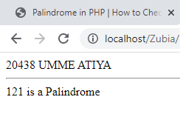

Q3

<?php

echo "20438 UMME ATIYA</br><hr>";

$num=7;

$flag=0;

for($x=2;$x<=($num/2);$x++)

{

if($num%$x ==0)

{

echo $num."is a Prime";

$flag=1;

break;

}

$flag=0;

}

if($num==1){

echo $num."neither prime nor composite";

}

elseif($flag==0){

echo $num." is a Prime";

}

?>

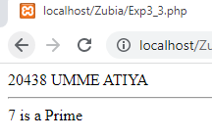

Q4

<?php

echo "20438 UMME ATIYA</br><hr>";

for($i=1;$i<=5;$i++){

for($j=0;$j<$i;$j++){

echo"* ";

}

echo"</br>";

}

?>

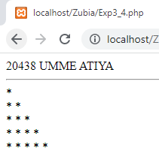

Q5

<?php

echo "20438 UMME ATIYA</br><hr>";

for($i=0; $i<5; $i++)

{

for($j=5; $j>$i+1; $j--)

{

echo "&nbsp&nbsp";

}

for($k=0;$k<=$i;$k++)

{

echo"&nbsp*&nbsp";

}

echo"<br>";

}

?>

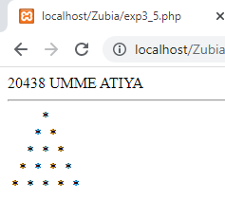

Q6

<?php

echo "20438 UMME ATIYA</br><hr>";

$a=0;

$b=1;

$temp=0;

echo $a." ".$b." ";

for($i=0;$i<=7;$i++)

{

$temp=$a+$b;

$a=$b;

$b=$temp;

echo $temp." ";

}

?>

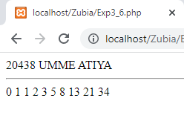

Q7

<?php

echo "20438 UMME ATIYA</br></br>";

echo "-----------------------</br>";

$loop=0;

$choice=1;

do{

echo "</br>1. Armstrong</br> 2.Palindrome</br> 3.Prime</br>";

//$choice=1;

if($choice==1)

{

echo "Choice = ".$choice." Armstong!</br>";

$num=153;

$total=0;

$x=$num;

while($x>0)

{

$rem=$x%10;

$total=$total+$rem*$rem*$rem;

$x=$x/10;

}

if($num==$total)

echo $num." is an armstong number</br>";

else

echo $num." is not an armstong number</br>";

$choice++;

$loop++;

}

elseif($choice==2)

{

echo "Choice = ".$choice." Palindrome!</br>";

$num=121;

$p=$num;

$rev=0;

while($num!=0)

{

$rev=($rev*10)+($num%10);

$num=(int)($num/10);

}

if($rev==$p)

echo $p." is a palindrome</br>";

else

echo $p." is not a palindrome</br>";

$choice++;

$loop++;

}

elseif($choice==3)

{

echo "Choice = ".$choice." Prime!</br>";

$num=7;

$flag=0;

for($i=2;$i<=($num/2);$i++)

{

if($num%$i==0){

echo $num." is not prime</br>";

$flag=1;

break;

}

$flag=0;

}

if($num==1){

echo $num." neither prime nor composite</br>";

}

elseif($flag==0){

echo $num." is prime</br>";

}

$choice++;

$loop++;

}

else{

echo "Choice = ".$choice."</br>";

echo "Invalid Choice</br>";

$choice++;

$loop++;

}

}while($loop<4);

?>

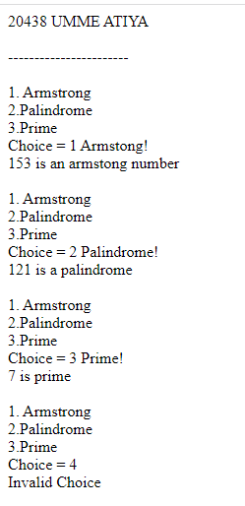

**EXPERIMENT 4**

Q1 . Write a PHP script to Create and display Index array, Associative array and Multidimensional array.

<?php

echo "20438 UMME ATIYA <br> <hr>";

echo "Indexed array: ";

$colors = array("Red", "Green", "Blue");

print_r($colors) ;

echo "<br><br>Associative  array: ";

$ages = array("Jane"=>22, "Joe"=>32, "John"=>28);

print_r($ages) ;

echo "<br><br>Multidimensional   array: ";

$contacts = array(

    array(

        "name" => "Peter Parker",

        "email" => "peterparker@mail.com",

    ),

    array(

        "name" => "Clark Kent",

        "email" => "clarkkent@mail.com",

    ),

    array(

        "name" => "Harry Potter",

        "email" => "harrypotter@mail.com",

    )

);

print_r($contacts) ;

?>

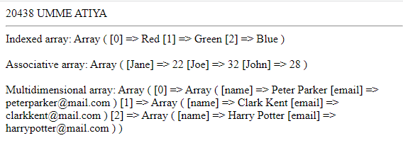

Q2. Write a PHP script to sort an array in ascending order.

<?php

echo "20438 UMME ATIYA <br> <hr>";

$array = array('a','z','c','b');

$count = count($array);

echo "<br>Unsorted Array:";

print_r($array);

for ($i = 0; $i < $count; $i++) {

    for ($j = $i + 1; $j < $count; $j++) {

        if ($array[$i] > $array[$j]) {

            $temp = $array[$i];

            $array[$i] = $array[$j];

            $array[$j] = $temp;

        }

    }

}

echo "<br>Sorted Array:";

print_r($array);

?>

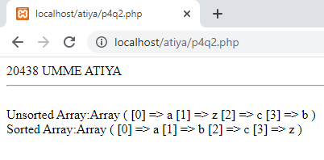

Q2.1 desc

<?php

echo "20438 UMME ATIYA <br> <hr>";

$array = array('a','z','c','b');

$count = count($array);

echo "<br>Unsorted Array:";

print_r($array);

for ($i = 0; $i < $count; $i++) {

    for ($j = $i + 1; $j < $count; $j++) {

        if ($array[$i] < $array[$j]) {

            $temp = $array[$i];

            $array[$i] = $array[$j];

            $array[$j] = $temp;

        }

    }

}

echo "<br>Sorted Array:";

print_r($array);

?>

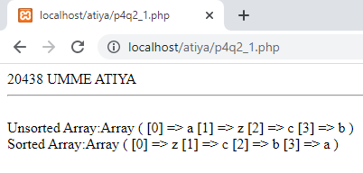

Q3. Write a PHP script to perform searching in an array.

<?php

echo "20438 UMME ATIYA <br> <hr>";

$array = array('a','z','c','b');

$count = count($array);

$k='z';

$flag=0;

echo "<br>Array:";

print_r($array);

for ($i = 0; $i < $count; $i++) {

if ($array[$i]==$k) {

$flag=1;

break;

}}

if($flag==1){

echo "<br>".$k." found";

}

?>

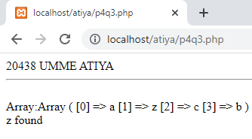

Q4. Write a PHP script to find minimum and maximum value in an array.

<?php

echo "20438 UMME ATIYA <br> <hr>";

$array = array('a','z','c','b');

$count = count($array);

$max=null;

echo "<br>Array:";

print_r($array);

for ($i = 0; $i < $count; $i++) {

for ($j = $i + 1; $j < $count; $j++) {

if ($array[$i] < $array[$j]) {

$min=$array[$i];

}

}

}

echo "<br>Minimum value: ".$min;

$max = $array[0];

for ($i = 1; $i < $count; $i++){

if ($max < $array[$i])

{$max = $array[$i];

}

}

echo "<br>Maximum value: ".$max;

?>

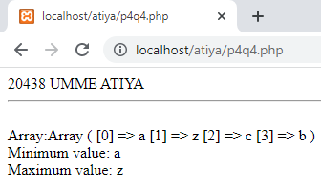

Q5. Write a PHP script to perform searching in a two dimensional array.

<?php

echo "20438 UMME ATIYA <br> <hr>";

$array = array(

        array('jane', 'joe'),

        array('john', 'jack'),

        array('jill', 'james') );

    $s = 'james';

    echo "2 Dimensional Array: <br><br>";

    foreach($array as $a) {

        for($i=0; $i<count($a); $i++) {

            echo $a[$i] . ", ";

        }

        echo "<br>";

    }

    echo "<br>Element to be searched: " . $s;

    $c = 0;

    foreach($array as $a) {

        for($i=0; $i<count($a); $i++) {

            if ($a[$i]==$s) {

                echo "<br><br>" . $s . " found";

                exit;

            }

        }

        $c++;

    }

    echo "<br><br>" . $s . " not found...";

?>

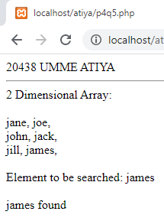

Q6. Write a PHP script to find minimum and maximum value in a two dimensional array.

<?php

echo "20438 UMME ATIYA <br><hr>";

$array = array(

    array(10, 20, 30),

    array(5, 25, 85),

    array(2, 9, 1)

);

$min = $array[0][0];

$max = $array[0][0];

echo "Two-Dimensional Array: <br>";

foreach ($array as $a) {

    for ($i = 0; $i < count($a); $i++) {

        echo $a[$i] . ", ";

    }

    echo "<br>";

}

foreach ($array as $a) {

    for ($i = 0; $i < count($a); $i++) {

        if ($a[$i] < $min) {

            $min = $a[$i];

        }

    }

}

echo "<br>Minimum Value: " . $min;

foreach ($array as $a) {

    for ($i = 0; $i < count($a); $i++) {

        if ($a[$i] > $max) {

            $max = $a[$i];

        }

    }

}

echo "<br><br>Maximum Value: " . $max;

?>

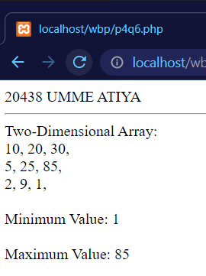

Q7. Write a PHP script to demonstrate the use of implode() function .

<?php

echo "20438 UMME ATIYA <br><hr>";

$arr = array('Hello', 'World!', 'how are', 'you!');

echo implode(" ", $arr);

?>

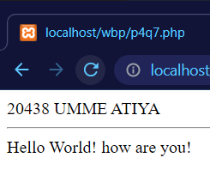

Q8. Write a PHP script to demonstrate the use of explode() function .

<?php

echo "20438 UMME ATIYA <br><hr>";

$str = ('Hii,How,Are,You');

$x = explode(',', $str, 0);

echo "Explode with 0<br>";

foreach ($x as $w) {

    echo $w . "<br>";

}

?>

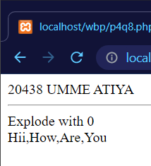

Q9. Write a PHP script to demonstrate the use of array_flip() function .

<?php

echo "20438 UMME ATIYA <br><hr>";

$arr = array(

    'atiya' => '38',

    'rameen' => '58',

    'zubia' => '29',

    'ramsha' => '27'

);

echo "Before Flipping<br>";

foreach ($arr as $x => $y) {

    echo "$x => $y <br>";

}

$result = array_flip($arr);

echo "<br><br>After Flipping<br>";

foreach ($result as $x => $y) {

    echo "$x => $y <br>";

}

?>

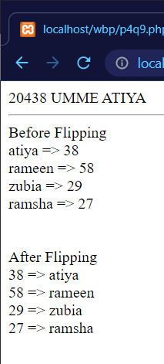

Q10. Write a PHP script to demonstrate the use of array_walk() function .

<?php

echo "20438 UMME ATIYA <br><hr>";

function myfunction($value, $key)

{

    echo "$key value is $value<br>";

}

$a = array("A" => "HI", "B" => "Hello", "C" => "Bye", "D" => "Goodbye");

array_walk($a, "myfunction") ?>

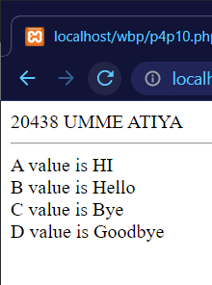

Q11. Write a PHP script to demonstrate

<?php

echo "20438 UMME ATIYA <br><hr>";

function myfunction($v)

{

    $v = strtoupper($v);

    return $v;

}

$a = array("A" => "umme ", "B" => "atiya");

print_r(array_map("myfunction", $a));

echo "<br>";

print_r($a);

?>

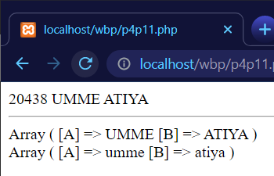

Extra

<?php

echo "20438 UMME ATIYA <br><hr>";

$arr = array(1, 87, 93, 10, 92);

echo "Array before sorting: ";

for ($i = 0; $i < count($arr); $i++) {

    echo "$arr[$i]" . ", ";

}

echo "<br><br>";

echo "After using sort()<br>";

sort($arr);

for ($i = 0; $i < count($arr); $i++) {

    echo "$arr[$i]" . ", ";

}

echo "<br>";

print_r($arr);

echo "<br><br>";

echo "After using rsort()<br>";

rsort($arr);

for ($i = 0; $i < count($arr); $i++) {

    echo "$arr[$i]" . ", ";

}

echo "<br>";

print_r($arr);

$arr1 = array("1" => "GoodBye", "3" => "Hello", "2" => "Hii");

echo "Associative array before sorting <br>";

print_r($arr1);

echo "<br><hr>";

asort($arr1);

echo "Ascending Sorting wrt Value : ";

print_r($arr1);

echo "<br>";

arsort($arr1);

echo "Descending Sorting wrt Value : ";

print_r($arr1);

echo "<br><hr>";

ksort($arr1);

echo "Ascending Sorting wrt Key : ";

print_r($arr1);

echo "<br>";

krsort($arr1);

echo "Descending Sorting wrt Key : ";

print_r($arr1);

?>

